|  |  |
| --- | --- |
| **Onsite Case** |  |
| JavaH2S1 |
| **Periode Berlaku** Semester Ganjil 2017/2018  ***Valid on*** *Odd Year 2017/2018* | **Software Laboratory Center**  **Assistant Recruitment 20-1** |

## Materi

*Material*

* Javascript type
* DOM Document Objects
* Variables, Arrays, and Strings
* Looping and Selection
* Functions
* Build in Function (Math, String, Array, Date, etc.)
* Event and Event handler
* Animation Timing (setTimeout, setInterval)
* Local Storage
* JavaScript Object Notation (JSON)
* jQuery 3 (selector, event, animation, dom manipulation, etc.)

**Soal**

*Case*

**PIcual Code**

**PIcual Code, Inc.** is an application developer company in Indonesia. They are currently developing an application that can help people to improve their skill in web technology. You as the programmer are asked to create the application using **HTML** & **JavaScript** **Language.**

1. **Home**

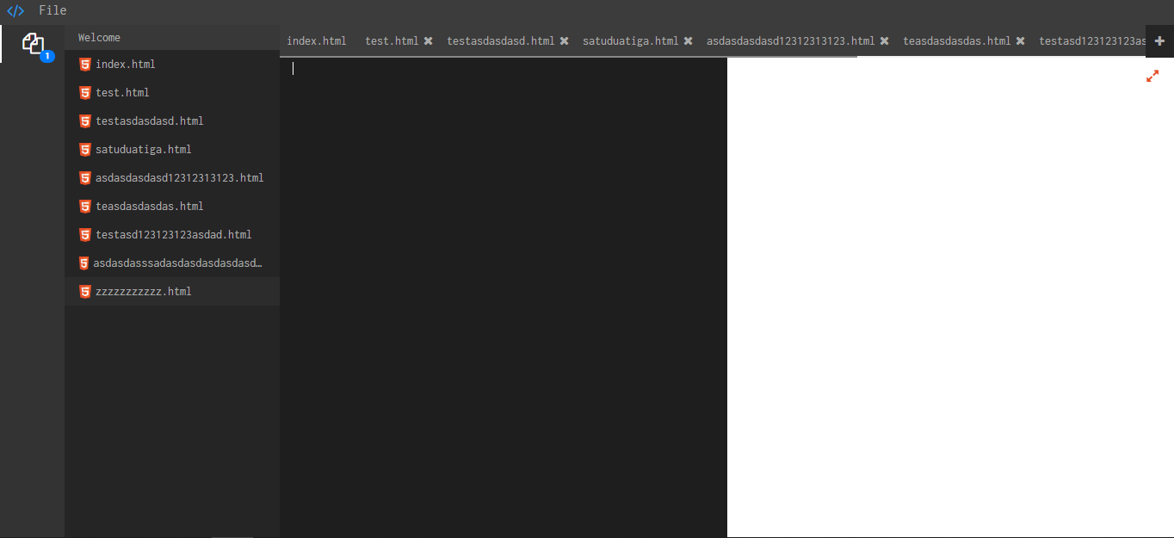

*Figure 1. Home page*

**Components:**

* **List Files** View.
* **Text Editor** View.
* **HTML** Preview**.**

**Description:**

* User can edit the code at text editor.
* User can preview **HTML**.
* User can make the **preview** **full screen**.

1. **Upload File Page**

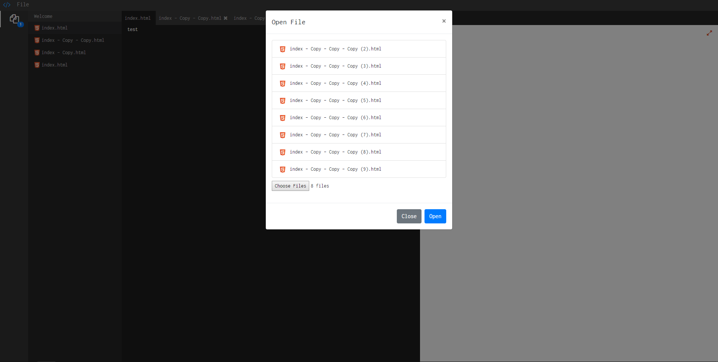

*Figure 2. Upload File Page*

**Components:**

* **List Upload Files** View.

**Description:**

* User can open file **html**.
* User can preview upload **open file**.

1. **Success Download File**

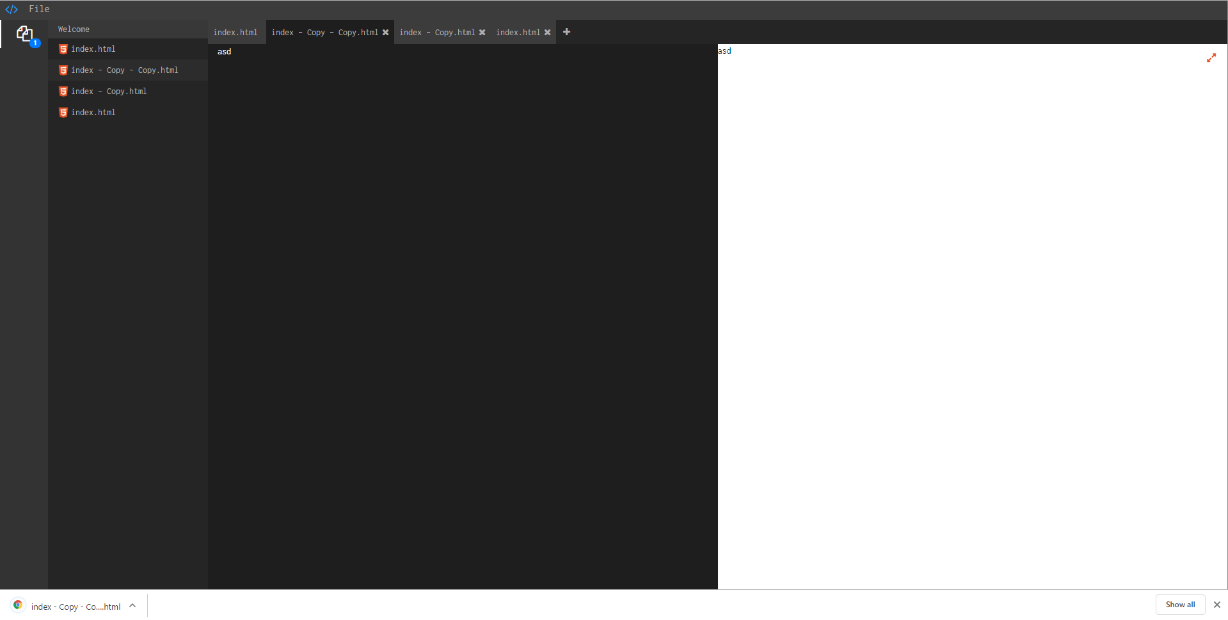

*Figure 2. Success File Download*

**Description:**

* User can download file **html** at current file.

1. **Create File**

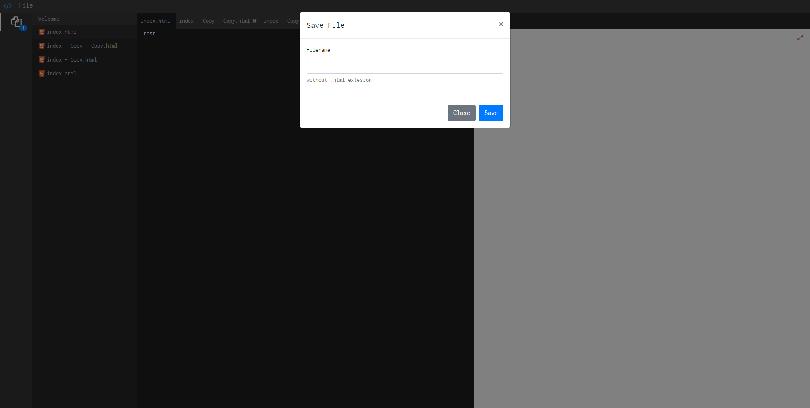

*Figure 2. Create File*

**Components:**

* Input filefor **filename**.

**Description:**

* User can **save** the **new file**.

**Referensi**

*References*

* <https://upload.wikimedia.org/wikipedia/commons/6/61/HTML5_logo_and_wordmark.svg>

**Komponen**

*Component*

|  |  |  |
| --- | --- | --- |
| **No.** | **Criteria** | **Percentage** |
| 1. | Download File | 25 |
| 2. | Text Editor Functionality | 15 |
| 3. | Preview HTML (can be Fullscreen) | 20 |
| 4. | View List Upload File HTML | 25 |
| 5. | See Choose File HTML | 15 |

**Please run the EXE file to see the sample program.**